Shandy Sulen

CIS6930: Intro to Computational Neuroscience

Dr. Banerjee

04/21/2018

Final Project

*All relevant code can be viewed and downloaded at https://github.com/shandysulen/NeuronNetworkSimulation.*

**1.**

The PSP generated from the dendrites of neurons are coupled with the AHP produced within the soma of the neuron to yield the total potential that is produced within 1-2 milliseconds. The plot shown in *Figure 1* is one example of the abundant spikes that are produced within the simulated network of neurons.

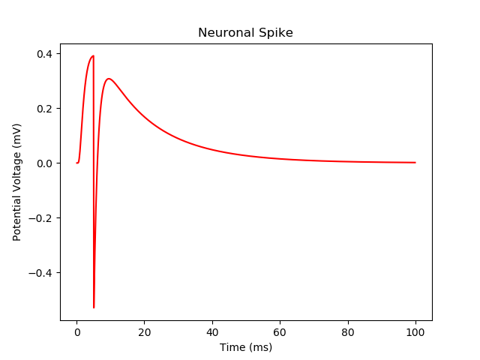

**Figure 1. A measure of the potential voltage generated from one neuronal spike**

In order to run this simulation, the total spike time lasts much longer. This is due to computation restrictions. Below is the result of the painstakingly long execution of the neural network simulation, in which input Poisson Neurons fire off at probabilistically low rates. The random *Q* and *alpha* are generated for each excitatory and inhibitory neuron. The network is simulated at time intervals of 0.1 msec for a total of 1,000 msec (1 sec). Attempting to run the network for 10,000 msec, or 10 sec, was far too slow and costly for my machine to handle. *Figure 2* shows how long it took the program to execute the simulation for a time range of 100 msec.

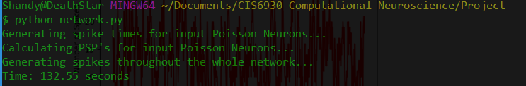

**Figure 2. Command Line Execution of Program**

In *Figure 2* below, the spike trains of 250 neurons are plotted together. The ratio of excitatory neurons to inhibitory neurons is representative of the total sample population of neurons, where 80% of the neurons represented are excitatory, and 20% are inhibitory.

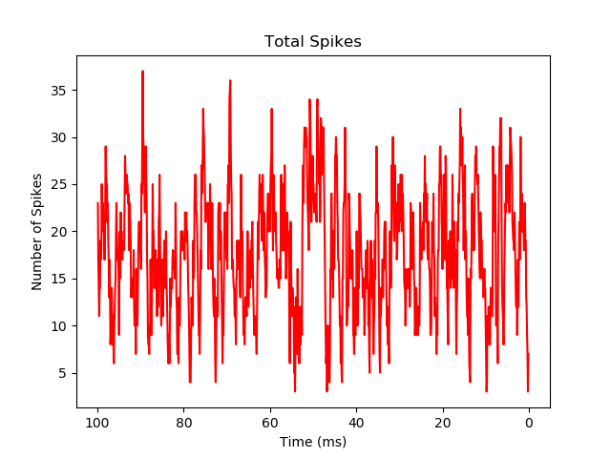

**Figure 3. Spike trains for 250 neurons**

*Figure 3* shows the total number of generated spikes within the neural network for the last 100 msec of its simulation.

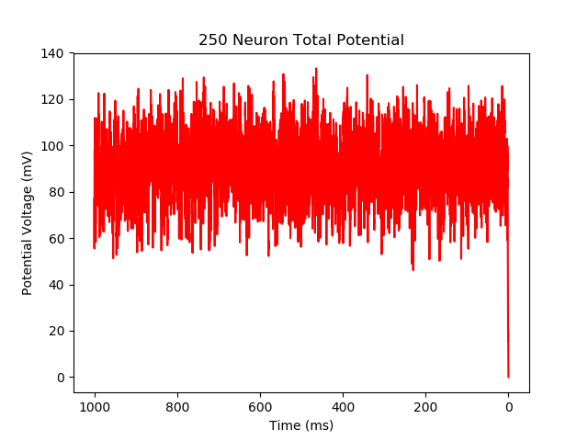

**Figure 4. Total number of generated spikes**

**2.**

The dynamics of the system is absolutely sensitive to initial conditions, as these initial Poisson neuronal spikes set the stage for the recurrent pattern of spikes elsewhere in the system. In order to achieve the exact same configuration of spikes twice (with one instance containing one perturbation), the initial Poisson input values are hard-coded within the simulated neuron network. *Figure 4* shows the first simulated run where there is no perturbations. The simulation presented in *Figure 5* contains no perturbations.

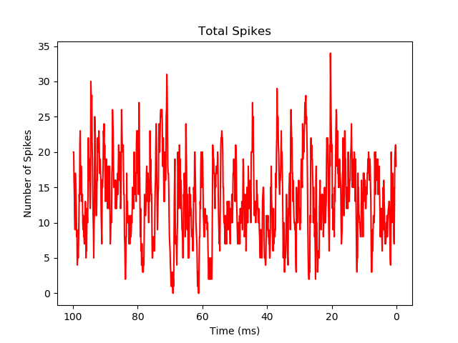

**Figure 5. First execution of the simulated network with no perturbations**

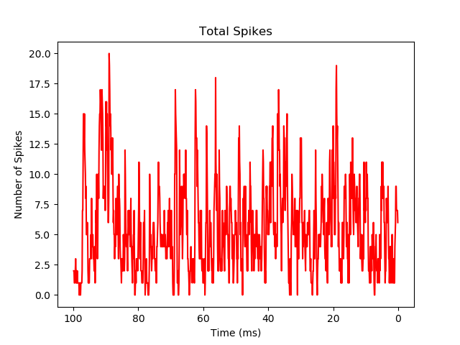

**Figure 6. Second execution of the simulated network with no perturbations**